ONLINE CORPORATION PORTAL

PROJECT REPORT
Submitted in partial fulfilment of the requirements for the award of degree of
BACHELOR OF COMPUTER SCIENCE

Submitted by
ARUN KUMAR.P
(Reg. No: 18BSS006)

Under the guidance of
Mrs. S. Kowsalya M.Sc., M. Phil.,
Assistant Professor,
Department of Computer Science and Application

SRI KRISHNA ARTS AND SCIENCE COLLEGE
An Autonomous College affiliated to Bharathiyar University
 |   Re-Accredited by NAAC with ‘A’ Grade  KUNIAMUTHUR (P.O.),  COIMBATORE-641 008.
APIRL 2021


Sri Krishna Arts and Science College
Re-accredited by NACC with ‘A’ grade
Affiliated To Bharathiyar University
Kuniamuthur, Coimbatore -641008

DECLARATION

I hereby declare that the Project report entitled “ ONLINE CORPORATION PORTAL ” submitted in partial fulfilment of the requirements for the award of degree of Bachelor of Science in Software Systems is an original work and it has not previously formed the basis for the award of any Degree, Diploma, Associate ship, Fellowship or similar titles to any other university or body during the period of my study.

Place : Coimbatore

Date :

Signature of the Candidate :

Sri Krishna Arts and Science College
Re-accredited by NACC with ‘A’ grade
Affiliated To Bharathiyar University
Kuniamuthur, Coimbatore -641

CERTIFICATE

This is to certify that the project report entitled “ ONLINE CORPORATION PORATAL ” submitted in partial full fillment of requirements for the degree of Bachelour of Science in Software Systems is a record of bonafide work carried out ARUN KUMAR.P 18BSS006 and that no part of this has been submitted for the award of any other degree or diploma and the work has not been published in popular journal or magazine.

GUIDE HOD PRINCIPAL

Viva-Voce conducted on: ____________

This Project Report is submitted for the Viva Voce examination conducted on ________________ at Sri Krishna Arts and Science College.

Internal Examiner External Examiner

ACKNOWLEDGEMENT

I convey my profound gratitude to Dr. K. Sundararaman, M.Com., M.Phil., Ph.D., CEO, Sri Krishna Institutions for giving me this opportunity to undergo this Training.
My heartfelt thanks to Dr.Baby Shakila M.Sc.,M.Phil.,Ph.D., Principal, Sri Krishna Arts and Science College for giving me this opportunity to undergo this Training
It is my prime to solemnly express my sense of gratitude to Dr. S. Saraswathi MCA.,M.Phil.,Ph.D.,PROFFESSOR & Head, Department of Computer Science and Applications, Sri Krishna Arts and Science College for giving me this opportunity to undergo this Training.
I would like to extend my thanks and unbound sense for the timely help and assistance given
Mrs .S. Kowsalya Department of Computer Application, Sri Krishna Arts and Science College in completing the training. His remarkable guidance at every stage of my training was coupled with suggestion and motivation.
I am earnestly thankful to teaching and non-teaching staffs of Department of Computer Science, Sri Krishna Arts and Science College for the support and guidance provided for me to complete the training.
I take this opportunity to thank my parents and friends for their constant support and encouragement throughout this training.

ONLINE CORPORATION PORTAL

ABSTRACT

This project is entitled as “CLEAN INDIA” which has developed in ASP.Net as front end SQL server as Backend. Computers have become an essential part of organizational information processing because of the power of technology and the volume of data to be processed. Through the technology, the manual process, defects and time consumption can be reduced. That’s in all the area of business, computer technology are widely been implemented. Hence the inception of computers had a great role in reducing large tasks to simpler one. This project is mainly developed for rectifying social issues of our nation. Usually human (public) complaints are given as by paper or other. For this complaints the higher officers are may be see this complaints or disobey the complaints else they doesn’t consider the complaints from the humans (publics). To overcome this problem we introduce to give complaints using online. Overall complaints will be reaches to higher officers like municipality office, etc through system like online. They received the complaints through notification. We send the complaints as description about the problem and photo about that. For this complaint the officers will see the complaints and send acknowledgement for that complaint then they take the action of the complaints within two days. After overcome the problem they send completed mail to the human (public) who are sent complaint. If the complainer doesn’t receive the acknowledgement or completed mail they can send the complaint of problem to media. They will precede the complaint.

ARUN KUMAR.P

INDEX

S. No. | Contents | Page No
1 | Introduction
1.1 | Project overview | 7
1.2 | Hardware Configuration | 8
1.3 | Software Configuration | 8
2 | System Study And Analysis
2.1 | Module Description | 9
2.2 | Existing System with disadvantage | 10
2.3 | Proposed System with advantage | 10
3 | System Design & Development
3.1 | Data flow Diagram | 11
3.2 | E-R Diagram | 14
3.3 | File Design | 16
3.4 | Input Design | 16
3.5 | Output Design | 17
3.6 | Database Design | 17
4 | System Testing
4.1 | Unit Testing | 18
4.2 | Output Testing | 19
4.3 | System Testing | 19
4.4 | Integrated Testing | 19
4.5 | Acceptance Testing | 19
5 | System Implementation and Maintenance | 20
6 | Conclusion | 22
7 | Future Enhancements | 23
8 | Bibliographies | 24
9 | Appendix
9.1 | Table design | 25
9.2 | sample Screen shots | 28
9.3 | Sample Source Codes | 31

INTRODUCTION
PROJECT OVERVIEW:

ASP.NET is used to produce interactive, data-driven web applications over the internet. It consists of a large number of controls such as text boxes, buttons, and labels for assembling, configuring, and manipulating code to create HTML pages. ASP.NET web forms extend the event-driven model of interaction to the web applications.

This project is entitled as “CLEAN INDIA” which has developed in ASP.Net as front end SQL server as Backend. Computers have become an essential part of organizational information processing because of the power of technology and the volume of data to be processed. Through the technology, the manual process, defects and time consumption can be reduced. That’s in all the area of business, computer technology are widely been implemented. Hence the inception of computers had a great role in reducing large tasks to simpler one. This project is mainly developed for rectifying social issues of our nation. Usually human (public) complaints are given as by paper or other. For this complaints the higher officers are may be see this complaints or disobey the complaints else they doesn’t consider the complaints from the humans (publics). To overcome this problem we introduce to give complaints using online. Overall complaints will be reaches to higher officers like municipality office, etc through system like online. They received the complaints through notification. We send the complaints as description about the problem and photo about that. For this complaint the officers will see the complaints and send acknowledgement for that complaint then they take the action of the complaints within two days. After overcome the problem they send completed mail to the human (public) who are sent complaint. If the complainer doesn’t receive the acknowledgement or completed mail they can send the complaint of problem to media. They will precede the complaint.

1.2 HARDWARE CONFIGURATION
PROCESSOR : DUAL CORE
HARD DISK CAPACITY : 250 GB
MONITOR : 18.5 “ACER MONITOR
INTERNAL MEMORY CAPACITY : 2 GB
KEYBOARD : LOGITECH OF 104 KEYS
CPU CLOCK : 2.3 GHz
MOUSE : LOGITECH MOUSE

1.3 SOFTWARE CONFIGURATION
OPERATING SYSTEM : WINDOWS 7
FRONT END : ASP.NET 2012
BACK END : SQL SERVER 2008

2.SYSTEM STUDY AND ANALYSIS

2.1 MODULE DESCRIPTION:
User:
This project allowed the social complaints send to the government authority persons.
- Register:
In this module user can register their details like name, username, password, mail id, mobile number. The registered details will be maintained in database.
2. Login:
In this login type user can login their details by registered details. They enter their username and password details if these details will be corrected system show login successfully alert message and move to main page. If that anyone details are incorrect it shows login incorrect alert message and stay on presented page.
3. Enquiry:
User can send social issues through this enquiry form and send the capture of that problem through this form. Also they view acknowledgement of the enquiry from organization.
Admin:
- Login:
Admin enter their username and password to that login form if these details will be corrected system show login successfully alert message and move to main page. If that anyone details are incorrect it shows login incorrect alert message and stay on presented page.
- Acknowledgement:
Admin can show user enquiry details with image and send acknowledgement of that enquiry like they seen that enquiry. After they complete the process of enquiry again they send the acknowledgement of that problem like they completed that enquiry process. This process will

be done within two days. If that acknowledgement doesn’t send to user they can send the enquiry to media.

2.2 EXISTING SYSTEM WITH DISADVANTAGE
Existing system did not provide any information to the people. People send only paper based complaint to the higher officer.
DIS ADVANTAGES:
- Paper complaints are missed
- Does not provide any acknowledgement to the people

2.3 PROPOSED SYSTEM WITH ADVANTAGE
This project is mainly developed for rectifying social issues of our nation. Usually human (public) complaints are given as by paper or other. For this complaints the higher officers are may be see this complaints or disobey the complaints else they doesn’t consider the complaints from the humans (publics).
ADVANTAGES:
- Social complaints are send through online
- Photos will upload
- Officers will response the complaints

3.SYSTEM DESIGN & DEVELOPMENT

3.1 DATA FLOW DIAGRAM
A data Flow diagram (DFD) is a process-orientation representation of an application system. It is a picture of the movement of data between external entities and the process and data stores within a system. It is a graphical representation of the "flow" of data through an information system. DFDs can also be used for the visualization of data processing. It provides no information about the timing of processes, or about whether processes will operate in sequence or in parallel. It is an element of structured analysis. It is graphical representation of a system or a system or a portion of a system.
The components of a typical dataflow diagram are as follows,
- The entity process.
- The flow.
- The data store.

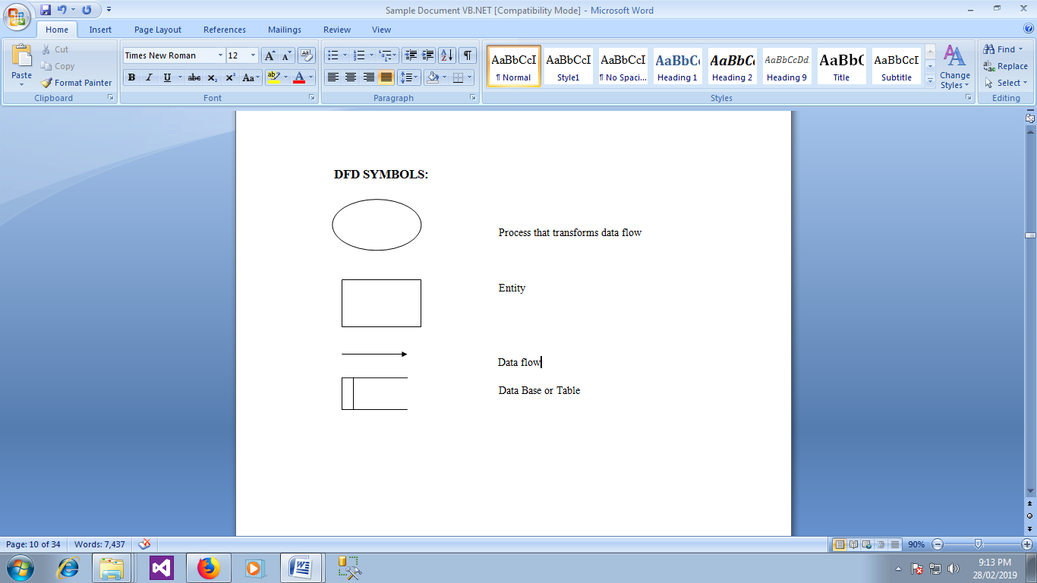

Level-0
Clean India

ADMIN/USER
Valid Store Clean-India _DB
Authenticated Retrieve

Level-1
Login

Admin
Valid Wrong Not Authenticate
Password Authenticated Password
View Complaints

Success Login send Complaints _TB

Receive
Acknowledgement

Send ACKNOW _TB
Acknowledge
Govern Authority

View Government _TB
Media
Report

Process

Report

Level-2
Register

User
Valid wrong Not Authenticate
Password Authenticated Password
Complaints

Success Login send Complaints _TB

Receive
View Acknowledgement

Send ACKNOW _TB
Acknowledge

Report

3.2 ENTITY RELATIONSHIP DIAGRAM
The Entity-Relationship (ER) model is a conceptual data model that views the real world as entities and relationships. A basic component of the model is the Entity-Relationship diagram, which is used to visually represent data objects. The model has been extended and today it is commonly used for database design. The entity relationship diagram is based on a perception of real world that consists of a collection of basic objects, called entities and of relationship among the objects. Entities are described in a database by a set of attributes. The set of all entities of the same type, and the set of all relationships of the same type, are termed as an entity set, and relationship set respectively. The overall logical structure of a database can be expressed graphically by an entity relationship diagram, which is built up using the notations
FEATURES OF ER MODEL ARE
- It maps well to relational model.
- It is simple and easy to understand with minimum of training. Therefore, database designer to communicate with the end user can use the model.
- In addition, the model can be used as a design plan by the database to implement a data model in specific database management software.

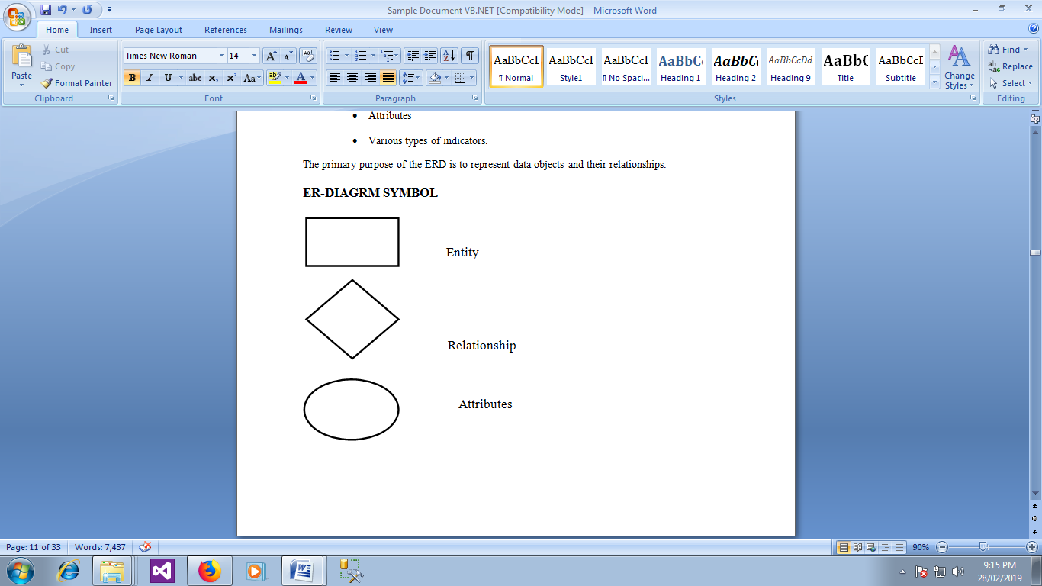

pwd
uid
Pwd
Name
Register
Registration
User

sub
cid
Get
Send
Monitor
Complaint

uid
Name
Reward
Mid
MNAME
Media
Update
Check
Pwd
Name
Admin

Provide

3.3 FILE DESIGN
A code generator is a suite of programs that matches the input to an appropriate code template and from these produces modules of code. The code is made simple in such a way that another programmer can easily understand and work on that in future. The crucial phase in the system development life cycle is the successful implementation of the new system design. The process of converting as new or revised system into an operational one is known as system implementation. This includes all those activities that take place to convert from an old system to a new system. The system can be implemented only after a through testing is done and if it is found to work according to the specifications.

3.4 INPUT DESIGN
Input design is the process of connecting the user-originated inputs into a computer to used formats. The goal of the input design is to make data entry Logical and free from errors. Errors in the input database controlled by input design this application is being developed in a user-friendly manner. The forms are being designed in such a way that during the processing the cursor is placed in the position where the data must be entered. An option of selecting an appropriate input from the values of validation is made for each of the data entered. Concerning clients comfort the project is designed with perfect validation on each field and to display error messages with appropriate suggestions. Help managers are also provided whenever user entry to a new field he/she can understand what is to be entered. Whenever user enter a error data error manager displayed user can move to next field only after entering a correct data

3.5 OUTPUT DESIGN
Computer output is the most important and direct source of information to the user. Efficient intelligible output design should improve the system's relationship with the user and admin in decision-making. Output design generally refers to the results generated by the system. For many end users on the basis of the output the evaluate the usefulness of the application. Efficient software must be able to produce and efficient effective reports.

3.6 DATABASE DESIGN
The database design involves creation of tables that are represented in physical database as stored files. They have their own existence. Each table constitute of rows and columns where each row can be viewed as record that consists of related information and column can be viewed as field of data of same type. The table is also designed with some position can have a null value. The database design of project is designed in such a way values are kept without redundancy and with normalized format. Refer the appendix for screen shots of Database Design

4.SYSTEM TESTING

4.1 UNIT TESTING

Here each program is tested individually so any error apply unit is debugged. The sample data are given for the unit testing. The unit test results are recorded for further references. During unit testing the functions of the program unit validation and the limitations are tested. Unit testing is testing changes made in a existing or new program this test is carried out during the programming and each module is found to be working satisfactorily. For example in the registration form after entering all the fields we click the submit button. When submit button is clicked ,all the data in form are validated. Only after validation entries will be added to the database. Unit testing comprises the set of tests performed by an individual prior to integration of the unit into large system. The situation is illustrated in as follows
Coding-> Debugging ->Unit Testing -> Integration testing->Output Testing
The four categories of test that a programmer will typically perform on a program unit
- Functional test
- Performance test
- Stress Test
- Structure test
Functional test involve exercising the code with nominal input values for which the expected results are known as well as boundary values and special values. Performance testing determines the amount of execution time spent in various parts of unit program through put and response time and device utilization by the program. A variation of stress testing called sensitivity testing in same situations a very small range of data contained in a the bounds of valid data may cause extreme and even erroneous processing or profound performance degradation. Structured testing is concerned with a exercising the internal logic of a program and traversing paths. Functional testing, stress testing performance testing are referred as “black box” testing and structure testing is referred as “white box” testing

4.2 OUTPUT TESTING

Asking the user about the format required by them tests the output generated by the system under consideration .It can be done in two ways, One on screen and other on printer format. The output format on the screen is found to be correct as the format designed n system test.

4.3 SYSTEM TESTING

In the system testing the whole system is tested for interface between each modules and program units are tested and recorded. This testing is done with sample data . The securities, communication between interfaces are tested System testing is actually a series of different tests whose primary purpose is to fully exercise the computer based system although each test has a different purpose all work to verify that all system elements properly integrated and perform allocate function.
It involves two kinds of activities namely

- Integrated testing
- Acceptance testing

4.4 INTEGRATED TESTING
Integrated testing is a systematic technique for constructing tests to uncover errors associated with interface.
Objective is to take unit tested modules and build a program structure that has been dictated by design

4.5 ACCEPTANCE TESTING
Acceptance testing involves planning an execution of a functional test, performance test and stress test to verify that the implemented system satisfies the requirement.
The acceptance testing is the final stage of the user the various possibilities of the data are entered and the results are tested

5.SYSTEM IMPLEMENTATION AND MAINTENANCE

SYSTEM IMPLEMENTATION

Implementation is the stage in the project where the theoretical design is turned into a working system. The most crucial stage is achieving a successful new system and giving a user confidence in that the new system will work efficiently and effectively in the implementation stage. The stage consist of

- Testing a developed program with sample data
- Detection and correction of error
- Creating whether the system meets a user requirements
- Making necessary changes as desired by users.
- Training user personal

IMPLEMENTATION PROCEDURES
The implementation phase is less creative than system design. A system design may be dropped at any time prior to implementation, although it becomes more difficult when it goes to the design phase. The final report of the implementation phase includes procedural flowcharts, record layouts, and a workable plan for implementing the candidate system design into a operational design.

SYSTEM MAINTENANCE

Maintenance is actually implementation of the review plan as important as it is programmers and analyst is to perform or identify with him or herself with the maintenance. There are psychologically personality and professional reasons for this. Analyst and programmers spend fair more time maintaining programmer then they do writing them Maintenances account for 50-80% of total system development. Maintenance is expensive .One way to reduce the maintenance costs are through maintenance mgt and software modification audits Types of maintenance are

- Perfective maintenance
- Preventive maintenance

PERFECTIVE MAINTENANCE:

Changes made to the system to add features or to improve the performance. In future any more features can be added in “DOT NET Communication” and it can easily adopt the changes.

PREVENTIVE MAINTENANCE:

Changes made to the system to avoid future problems. Any changes can be made in the future and our project can adopt the changes.

6.CONCLUSION
The main objective of the project is to bring a full-fledged computerized organization, and to enable the transaction details to maintain records, which makes of the web application easier. Thus, the proposed system has been developed with good amount of flexibility without compromising on the response time. Computerization of the entire system will enhance more accuracy and reduces major part of clerical works. Fast, clear and legible reports can be generated without any ambiguity. Integrated database design and ease of maintenance is a major advantage of the system. User friendliness is a unique feather of the system. Hence by developing a system that is user-friendly in nature, many users are able to work on the system with little of computer knowledge and training.

7.FUTURE ENHANCEMENT

The project has been developed and the objectives are achieved successfully. The project has been developed with front end as ASP.Net and backend as SQL Server. The frontend can also be changed. ASP.Net MVC 2017 can replace the front-end tool such as ANGULAR JAVA SCRIPT and F# language and SQL SERVER 2012 STORE PROCEDURE for more speed. The system is currently developed and ready for implementation to include the system is highly feasible and user friendly. To provide better facility regarding security, it uses security provider software and we access any place and any where use that. It can have an enhancement on proper in the future according to the user’s requirements.

8. BIBLIOGRAPHY

- .Elias Awath, “SYSTEM ANALYSIS AND DESIGN”,Tata Mc Graw Hill Publication, Sixth Edition,2013
- .S.Ramachandran,”COMPUTER AIDED DESIGN”, Air Walk Publication, Third Edition,2013
- .Richard Fairley,”SOFTWARE ENGINEERING CONCEPTS”,Tata Mc Graw Hill Publication, Second Edition,2007
- .Distributed .NET Programming in ASP .NET by Tom Barnaby
- Professional ASP.NET, 2nd Edition by Fred Barwell, et al
- The .NET Languages: A Quick Translation Guide by Brian Bischof
- Programming ASP.NET: A Guide for Experienced Programmers
by Gary Cornell, Jonathan Morrison
- Learning Visual Basic.NET Through Applications by Clayton Crooks II
- Visual Basic .NET How to Program (2nd Edition) by Harvey M. Deitel, Paul J. Deitel, Tem R. Nieto

REFERENCE WEBSITE:
www.w3schools.com
www.dotnetsuresh.com
www.aspsnippets.com

9.APPENDIX

A.TABLE DESIGN

Table design: complaint
Primary key: cmpid
Foreign key: uid

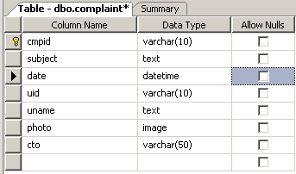

Table name: media details
Primary key: mediaid

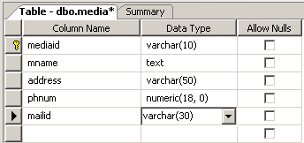

Table name: registration
Primary key: uid
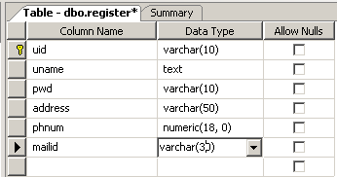

Table name: user login
Foreign key: uid

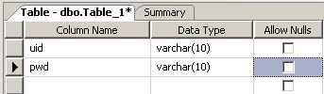

Table name: admin login
Foreign key: aname

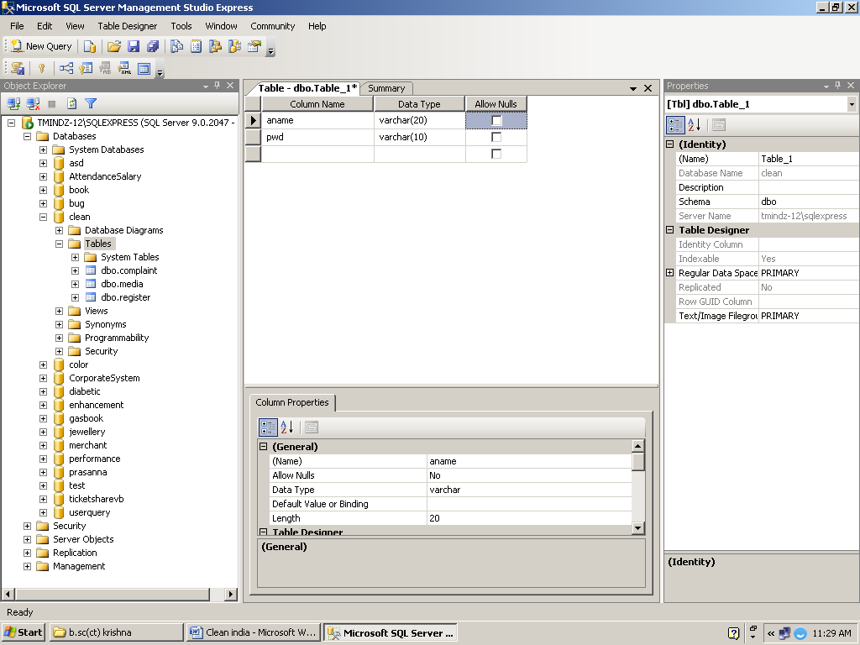

B. SAMPLE SCREENSHOT

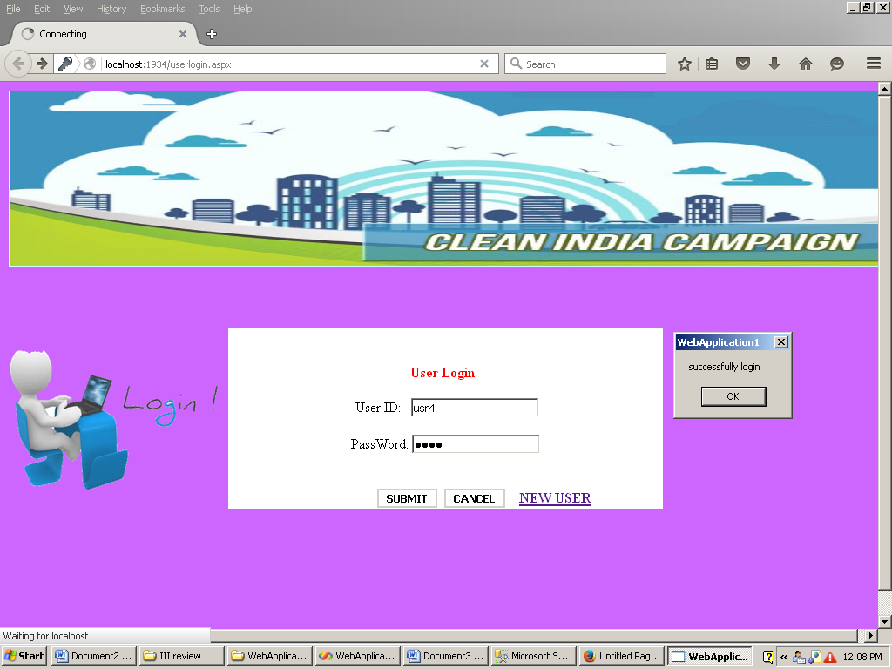

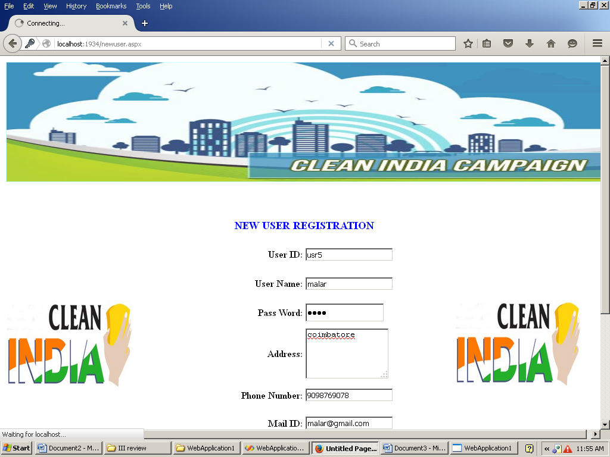

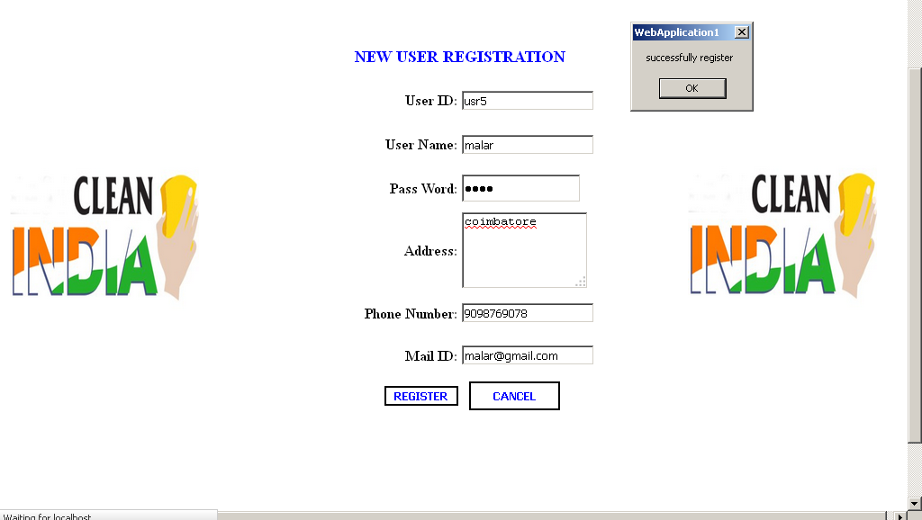

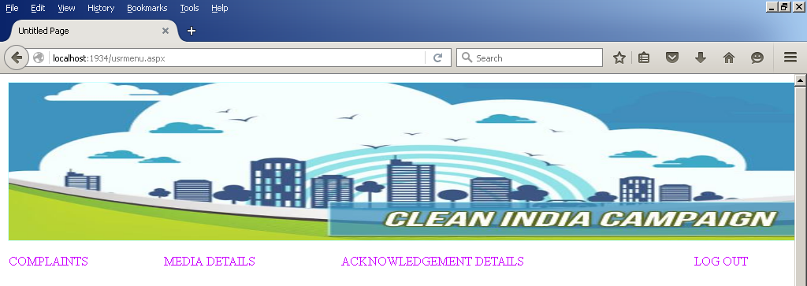
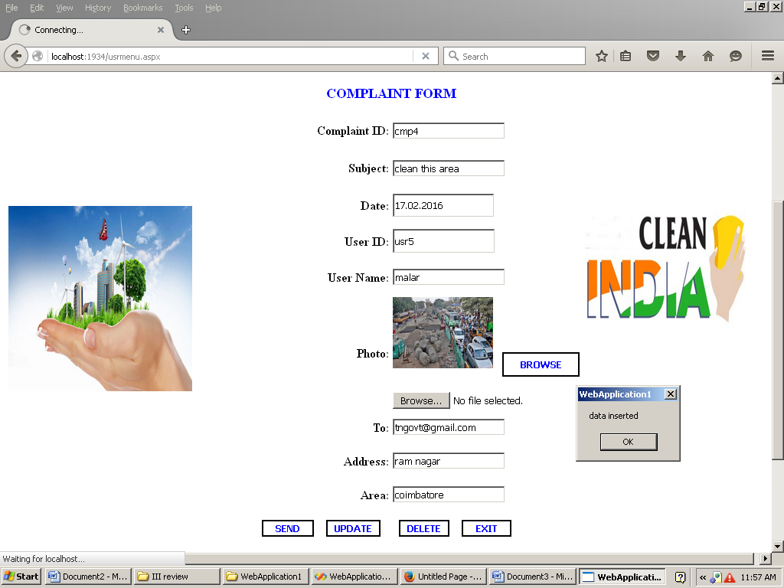

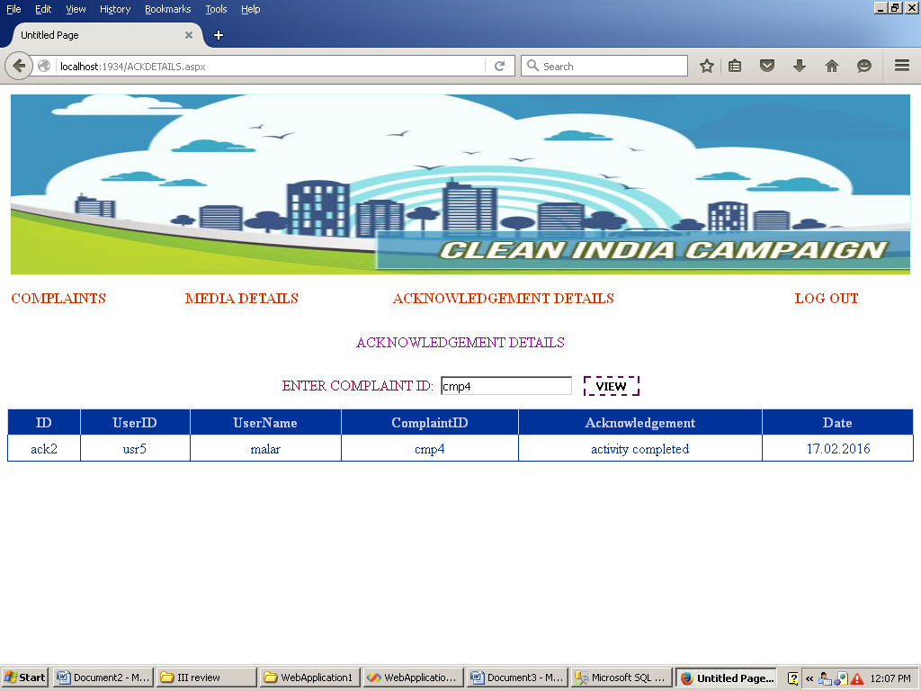
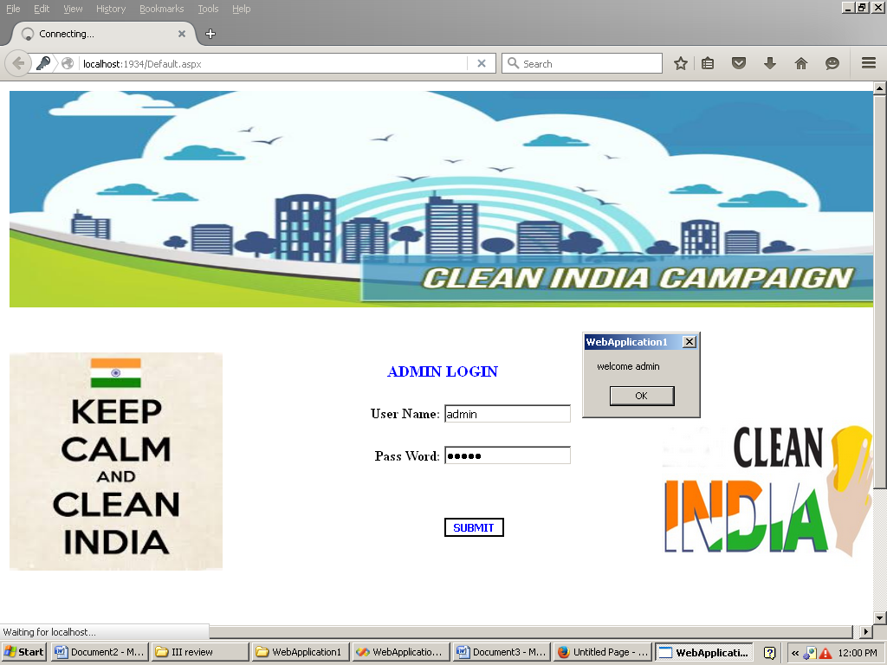

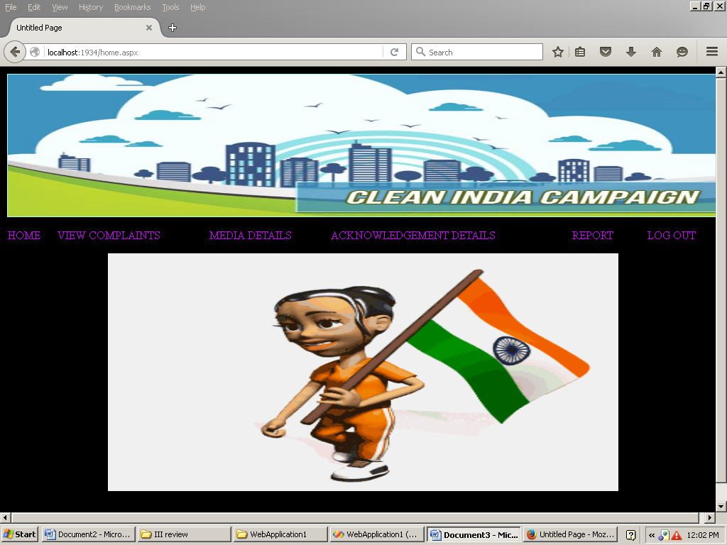

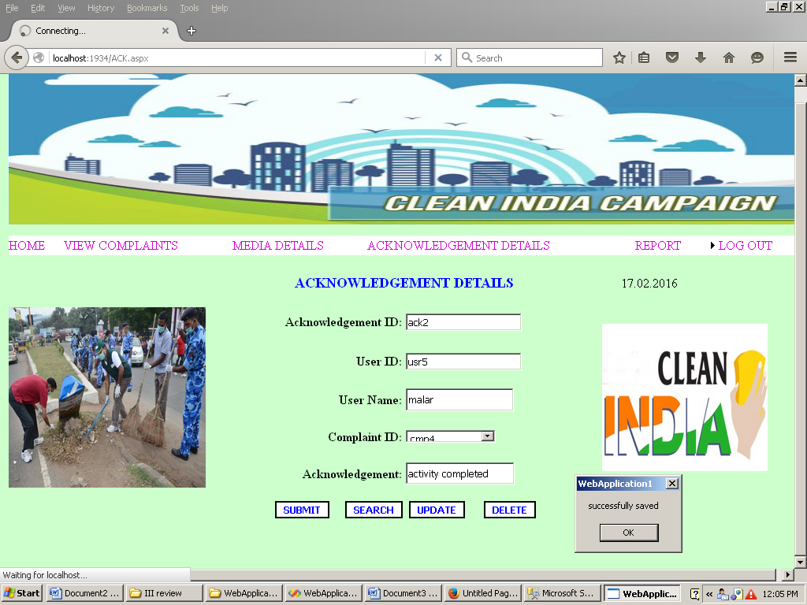

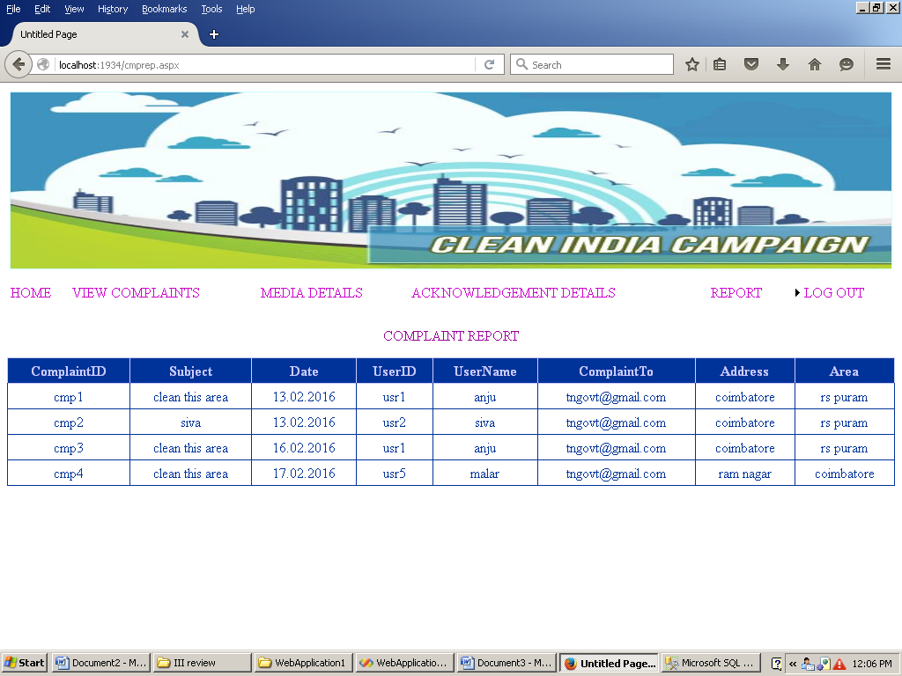
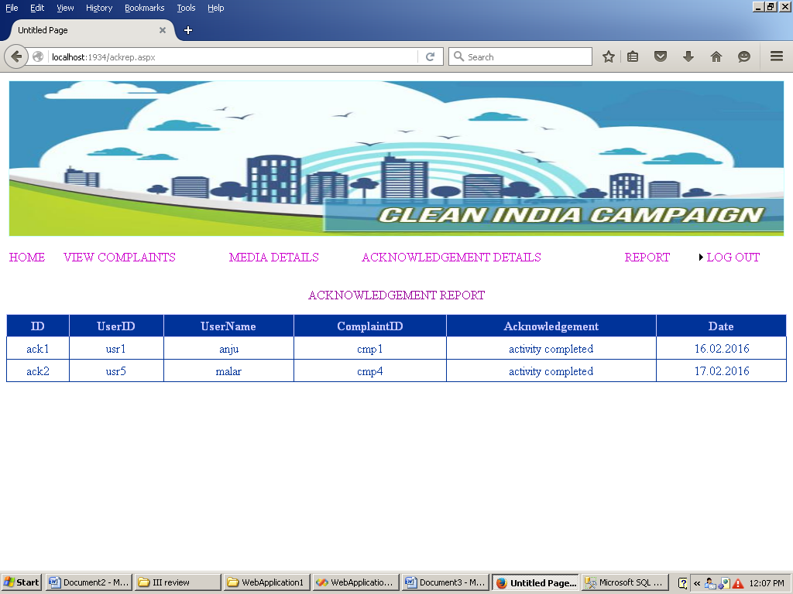

SAMPLE SOURCE CODE
New user registration:
Asp design
<%@ Page Language="vb" AutoEventWireup="false" CodeBehind="newuser.aspx.vb" Inherits="WebApplication1.newuser" %>

<!DOCTYPE html PUBLIC "-//W3C//DTD XHTML 1.0 Transitional//EN" "http://www.w3.org/TR/xhtml1/DTD/xhtml1-transitional.dtd">

<html xmlns="http://www.w3.org/1999/xhtml" >
<head id="Head1" runat="server">
<title>Untitled Page</title>
<style type="text/css">
.style1
{
width: 25%;
height: 40px;
}
.style2
{
height: 40px;
}
.style3
{
width: 25%;
height: 42px;
}
.style4
{
width: 25%;
height: 44px;
}
.style5
{
height: 44px;
text-align: center;
}
.style6
{
font-weight: bold;
color: #0000FF;
font-size: large;
}
.style7
{
font-weight: bold;
}
.style8
{
width: 25%;
height: 45px;
text-align: right;
}
.style9
{
width: 25%;
height: 44px;

text-align: right;
}
.style10
{
height: 44px;
}
.style11
{
width: 25%;
}
.style12
{
width: 25%;
}
.style13
{
height: 112px;
}
.style14
{
width: 25%;
height: 42px;
text-align: right;
}
.style15
{
height: 40px;
text-align: right;
}
</style>
</head>
<body>
<form id="form1" runat="server">
<div>
<table align="center" style="position: static; width: 1000px;">
<tr>
<td class="style13" colspan="4" bgcolor="#CCFFFF">
<asp:Image ID="Image4" runat="server" Height="200px"
ImageUrl="~/photos/clean new.JPG" Width="1000px" />
</td>
</tr>
<tr>
<td class="style10">
&nbsp;</td>
<td class="style10">
&nbsp;</td>
<td class="style10">
&nbsp;</td>
<td class="style10">
&nbsp;</td>
</tr>
<tr>
<td class="style4"></td>
<td class="style5" colspan="2">
<asp:Label ID="Label1" runat="server" CssClass="style6"
Text="NEW USER REGISTRATION"></asp:Label>
</td>
<td class="style4"></td>
</tr>
<tr>

<td class="style11"></td>
<td class="style8">
<asp:Label ID="Label2" runat="server" CssClass="style7" Text="User ID:"></asp:Label>
</td>
<td class="style11">
<asp:TextBox ID="TextBox1" runat="server"></asp:TextBox>
</td>
<td class="style12" rowspan="6">
<asp:Image ID="Image3" runat="server" Height="187px"
ImageUrl="~/photos/clean-india.jpg" Width="210px" />
</td>
</tr>
<tr>
<td class="style11" rowspan="4">
<asp:Image ID="Image5" runat="server" Height="187px"
ImageUrl="~/photos/clean-india.jpg" Width="210px" />
</td>
<td class="style8">
<asp:Label ID="Label6" runat="server" CssClass="style7" Text="User Name:"></asp:Label>
</td>
<td class="style11">
<asp:TextBox ID="TextBox2" runat="server"></asp:TextBox>
</td>
</tr>
<tr>
<td class="style9">
<asp:Label ID="Label3" runat="server" CssClass="style7" Text="Pass Word:"></asp:Label>
</td>
<td class="style4">
<asp:TextBox ID="TextBox3" runat="server" Height="25px" TextMode="Password"
Width="126px"></asp:TextBox>
</td>
</tr>
<tr>
<td class="style14">
<asp:Label ID="Label4" runat="server" CssClass="style7" Text="Address:"></asp:Label>
</td>
<td class="style3">
<asp:TextBox ID="TextBox4" runat="server" TextMode="MultiLine" Height="81px"
Width="134px"></asp:TextBox>
</td>
</tr>
<tr>
<td class="style9">
<asp:Label ID="Label8" runat="server" CssClass="style7" Text="Phone Number:"></asp:Label>
</td>
<td class="style4">
<asp:TextBox ID="TextBox5" runat="server"></asp:TextBox>
</td>
</tr>
<tr>
<td class="style3"></td>
<td class="style14">

<asp:Label ID="Label7" runat="server" CssClass="style7" Text="Mail ID:"></asp:Label>
</td>
<td class="style3">
<asp:TextBox ID="TextBox6" runat="server"></asp:TextBox>
</td>
</tr>
<tr>
<td class="style2">&nbsp;</td>
<td class="style15">
<asp:Button ID="Button1" runat="server" BackColor="White" BorderColor="Black"
BorderStyle="Double" CssClass="style7" ForeColor="Blue" Text="REGISTER" />
</td>
<td class="style2"><span lang="en-us">&nbsp;
<asp:Button ID="Button2" runat="server" BackColor="White" BorderColor="Black"
BorderStyle="Double" CssClass="style7" ForeColor="Blue" Text="CANCEL"
Height="32px" Width="101px" />
</span></td>
<td class="style2">
&nbsp;</td>
</tr>
<tr>
<td class="style1">&nbsp;</td>
<td class="style1">&nbsp;</td>
<td class="style1">&nbsp;</td>
<td class="style1">&nbsp;</td>
</tr>
<tr>
<td class="style1">&nbsp;</td>
<td class="style1">&nbsp;</td>
<td class="style1">&nbsp;</td>
<td class="style1">&nbsp;</td>
</tr>
<tr>
<td class="style3"></td>
<td class="style3"></td>
<td class="style3"></td>
<td class="style3"></td>
</tr>
<tr>
<td class="style1">&nbsp;</td>
<td class="style1">&nbsp;</td>
<td class="style1">&nbsp;</td>
<td class="style1">&nbsp;</td>
</tr>
</table>

</div>
</form>
</body>
</html>

Login:
<%@ Page Language="vb" AutoEventWireup="false" CodeBehind="userlogin.aspx.vb" Inherits="WebApplication1.userlogin" %>

<!DOCTYPE html PUBLIC "-//W3C//DTD XHTML 1.0 Transitional//EN" "http://www.w3.org/TR/xhtml1/DTD/xhtml1-transitional.dtd">

<html xmlns="http://www.w3.org/1999/xhtml" >
<head runat="server">
<title>Untitled Page</title>
<style type="text/css">
.style1
{
height: 101px;
}
.style2
{
text-align: center;
}
.style3
{
height: 30px;
width: 25%;
}
</style>
</head>
<body bgcolor="#cc66ff">
<form id="form1" runat="server">

<table align="center" style="position: static; width:100%;">
<tr>
<td class="style1" colspan="4" bgcolor="#CCFFFF">
<asp:Image ID="Image4" runat="server" Height="200px"
ImageUrl="~/photos/clean new.JPG" Width="1000px" />
</td>
</tr>
<tr>
<td style="width:25%; height:30px;">&nbsp;</td>
<td class="style3">&nbsp;</td>
<td style="width:25%; height:30px;">&nbsp;</td>
<td style="width:25%; height:30px;">&nbsp;</td>
</tr>
<tr>
<td style="width:25%; height:30px;">&nbsp;</td>
<td class="style3">&nbsp;</td>
<td style="width:25%; height:30px;">&nbsp;</td>
<td style="width:25%; height:30px;">&nbsp;</td>
</tr>
<tr>
<td style="width:25%; " rowspan="4">
<asp:Image ID="Image5" runat="server" Height="190px"
ImageUrl="~/New Folder/login.gif" Width="248px" />
</td>
<td bgcolor="White" class="style2" colspan="2" rowspan="4">&nbsp;&nbsp;&nbsp;&nbsp;&nbsp;&nbsp;&nbsp;&nbsp;&nbsp;&nbsp;&nbsp;&nbsp;&nbsp;&nbsp;&nbsp;<br />
<br />
<asp:Label ID="Label2" runat="server"
style="font-size: medium; font-weight: 700; font-family: 'Times New Roman', Times, serif; color: #FF0000"
Text="User Login"></asp:Label>
&nbsp;<br />
<br />

&nbsp;<asp:Label ID="Label1" runat="server" Text="User ID:"></asp:Label>
&nbsp;
<asp:TextBox ID="TextBox1" runat="server"></asp:TextBox>
<br />
<br />
PassWord: <asp:TextBox ID="TextBox2" runat="server"
TextMode="Password"></asp:TextBox>
<br />
<br />
<br />
&nbsp;&nbsp;&nbsp;&nbsp;&nbsp;&nbsp;&nbsp;&nbsp;&nbsp;&nbsp;&nbsp;&nbsp;&nbsp;&nbsp;&nbsp;&nbsp;&nbsp;&nbsp;&nbsp;&nbsp;
&nbsp;<asp:Button ID="Button1" runat="server" BackColor="White"
BorderStyle="Double" style="text-align: right" Text="SUBMIT"
Font-Bold="True" />
&nbsp;<asp:Button ID="Button2" runat="server" BackColor="White"
BorderStyle="Double" style="text-align: right; font-weight: 700;"
Text="CANCEL" />
&nbsp;&nbsp;
<asp:HyperLink ID="HyperLink1" runat="server" NavigateUrl="~/newuser.aspx"
style="font-weight: 700">NEW
USER
</asp:HyperLink>
</td>
<td style="width:25%; height:30px;">&nbsp;</td>
</tr>
<tr>
<td style="width:25%; height:30px;">&nbsp;</td>
</tr>
<tr>
<td style="width:25%; height:30px;">&nbsp;</td>
</tr>
<tr>
<td style="width:25%; height:30px;">&nbsp;</td>
</tr>
<tr>
<td style="width:25%; height:30px;">&nbsp;</td>
<td class="style3">&nbsp;</td>
<td style="width:25%; height:30px;">&nbsp;</td>
<td style="width:25%; height:30px;">&nbsp;</td>
</tr>
<tr>
<td class="style3"></td>
<td class="style3"></td>
<td class="style3"></td>
<td class="style3"></td>
</tr>
<tr>
<td style="width:25%; height:30px;">&nbsp;</td>
<td class="style3">&nbsp;</td>
<td style="width:25%; height:30px;">&nbsp;</td>
<td style="width:25%; height:30px;">&nbsp;</td>
</tr>
<tr>
<td style="width:25%; height:30px;">&nbsp;</td>
<td class="style3">&nbsp;</td>
<td style="width:25%; height:30px;">&nbsp;</td>

<td style="width:25%; height:30px;">&nbsp;</td>
</tr>
</table>

&nbsp;&nbsp;&nbsp;&nbsp;&nbsp;&nbsp;&nbsp;

</form>
</body>
</html>

Imports System.Data
Imports System.Data.SqlClient
Partial Public Class newuser
Inherits System.Web.UI.Page
Dim con As New SqlConnection("Data Source=TMINDZ-17\SQLEXPRESS;Initial Catalog=clean;User ID=sa; pwd=sql;")
Dim cmd As New SqlCommand
Dim str As String
Dim adp As New SqlDataAdapter
Dim ds As New DataSet
Dim i As Integer
Protected Sub Page_Load(ByVal sender As Object, ByVal e As System.EventArgs) Handles Me.Load
Try
Dim p As String
str = "select uid from register"
cmd = New SqlCommand(str, con)
adp = New SqlDataAdapter(cmd)
ds = New DataSet
adp.Fill(ds, "register")
i = ds.Tables("register").Rows.Count
p = ds.Tables("register").Rows(i - 1)(0)
p = Mid(p, 4)
p = Val(p) + 1
'If Len(p) = 1 Then
' p = "000" + p
'ElseIf Len(p) = 2 Then
' p = "00" + p
'ElseIf Len(p) = 3 Then
' p = "0" + p
'End If
TextBox1.Text = "usr" + p

Catch ex As Exception
TextBox1.Text = "usr1"
End Try
End Sub

Protected Sub Button1_Click(ByVal sender As Object, ByVal e As EventArgs) Handles Button1.Click
If TextBox1.Text = "" Or TextBox2.Text = "" Or TextBox3.Text = "" Or TextBox4.Text = "" Or TextBox5.Text = "" Or TextBox6.Text = "" Then
MsgBox("enter all data")
Else
con.Open()
str = "insert into register values( '" & TextBox1.Text & "','" & TextBox2.Text & "','" & TextBox3.Text & "','" & TextBox4.Text & "','" & TextBox5.Text & "','" & TextBox6.Text & "')"

cmd = New SqlCommand(str, con)
cmd.ExecuteNonQuery()
MsgBox("successfully register")
Response.Redirect("usrmenu.aspx")
End If

TextBox1.Text = ""
TextBox2.Text = ""
TextBox3.Text = ""
TextBox4.Text = ""
TextBox5.Text = ""
TextBox6.Text = ""
End Sub

Protected Sub Button2_Click(ByVal sender As Object, ByVal e As EventArgs) Handles Button2.Click
TextBox1.Text = ""
TextBox2.Text = ""
TextBox3.Text = ""
TextBox4.Text = ""
TextBox5.Text = ""
TextBox6.Text = ""
Response.Redirect("userlogin.aspx")
End Sub
End Class
User login
Imports System.Data
Imports System.Data.SqlClient
Partial Public Class userlogin
Inherits System.Web.UI.Page
Dim con As New SqlConnection("Data Source=TMINDZ-17\SQLEXPRESS;Initial Catalog=clean;User ID=sa; pwd=sql;")
Dim str As String
Dim i As Integer
Protected Sub Page_Load(ByVal sender As Object, ByVal e As System.EventArgs) Handles Me.Load

End Sub

Protected Sub Button1_Click(ByVal sender As Object, ByVal e As EventArgs) Handles Button1.Click
Try
Dim cmd = New SqlCommand("select uid,pwd from register where uid='" & TextBox1.Text & "' and pwd='" & TextBox2.Text & "'", con)
Dim da = New SqlDataAdapter(cmd)
Dim ds = New DataSet()
da.Fill(ds, "register")
i = ds.Tables("register").Rows.Count
If ds.Tables(0).Rows.Count > 0 Then
MsgBox("successfully login ")
Response.Redirect("usrmenu.aspx")
Else
MsgBox("invalid data")
End If
Catch ex As Exception
End Try

End Sub

End Class
Complaint form
Imports System.Data
Imports System.Data.SqlClient
Imports System.IO
Partial Public Class usrmenu
Inherits System.Web.UI.Page
Dim con As New SqlConnection("Data Source=TMINDZ-17\SQLEXPRESS;Initial Catalog=clean;User ID=sa; pwd=sql;")
Dim cmd, com As New SqlCommand
Dim qry, str As String
Dim adp As SqlDataAdapter
Dim ds As DataSet
Dim i As Integer
Protected Sub Page_Load(ByVal sender As Object, ByVal e As System.EventArgs) Handles Me.Load
Try
Dim p As String
Str = "select cmpid from complaint"
com = New SqlCommand(Str, con)
adp = New SqlDataAdapter(com)
ds = New DataSet
adp.Fill(ds, "complaint")
i = ds.Tables("complaint").Rows.Count
p = ds.Tables("complaint").Rows(i - 1)(0)
p = Mid(p, 4)
p = Val(p) + 1
'If Len(p) = 1 Then
' p = "000" + p
'ElseIf Len(p) = 2 Then
' p = "00" + p
'ElseIf Len(p) = 3 Then
' p = "0" + p
'End If
TextBox1.Text = "cmp" + p

Catch ex As Exception
TextBox1.Text = "cmp1"
End Try
TextBox3.Text = Date.Today
End Sub

Protected Sub Button5_Click(ByVal sender As Object, ByVal e As EventArgs) Handles Button5.Click
If TextBox1.Text = "" Or TextBox2.Text = "" Or TextBox3.Text = "" Or TextBox4.Text = "" Or TextBox5.Text = "" Or TextBox6.Text = "" Or TextBox7.Text = "" Or TextBox8.Text = "" Then
MsgBox("enter all fields", MsgBoxStyle.OkOnly)
Else
con.Open()
qry = "insert into complaint values('" + TextBox1.Text + "','" + TextBox2.Text + "','" + TextBox3.Text + "','" + TextBox4.Text + "','" + TextBox5.Text + "','" + FileUpload1.FileName + "','" + TextBox6.Text + "','" + TextBox7.Text + "','" + TextBox8.Text + "')"
cmd = New SqlCommand(qry, con)
cmd.ExecuteNonQuery()
MsgBox("data inserted")
TextBox1.Text = ""

TextBox2.Text = ""
TextBox3.Text = ""
TextBox4.Text = ""
TextBox5.Text = ""
TextBox6.Text = ""
TextBox7.Text = ""
TextBox8.Text = ""
Image5.ImageUrl = ""
End If
End Sub

Protected Sub Button4_Click(ByVal sender As Object, ByVal e As EventArgs) Handles Button4.Click
con.Open()
qry = "update complaint set cmpid='" + TextBox1.Text + "',subject='" + TextBox2.Text + "',date='" + TextBox3.Text + "',uid='" + TextBox4.Text + "',uname='" + TextBox5.Text + "',photo='" + FileUpload1.FileName + "',cto='" + TextBox6.Text + "',addr='" + TextBox7.Text + "', area='" + TextBox8.Text + "' where cmpid='" + TextBox1.Text + "' "
cmd = New SqlCommand(qry, con)
cmd.ExecuteNonQuery()
MsgBox("data updated")
TextBox1.Text = ""
TextBox2.Text = ""
TextBox3.Text = ""
TextBox4.Text = ""
TextBox5.Text = ""
TextBox6.Text = ""
TextBox7.Text = ""
TextBox8.Text = ""
Image5.ImageUrl = ""
End Sub

Protected Sub Button6_Click(ByVal sender As Object, ByVal e As EventArgs) Handles Button6.Click
con.Open()
qry = "delete from complaint where cmpid='" + TextBox1.Text + "' "
cmd = New SqlCommand(qry, con)
cmd.ExecuteNonQuery()
MsgBox("data deleted")
TextBox1.Text = ""
TextBox2.Text = ""
TextBox3.Text = ""
TextBox4.Text = ""
TextBox5.Text = ""
TextBox6.Text = ""
TextBox7.Text = ""
TextBox8.Text = ""
Image5.ImageUrl = ""
End Sub

Protected Sub Button7_Click(ByVal sender As Object, ByVal e As EventArgs) Handles Button7.Click

End Sub

Protected Sub Button3_Click(ByVal sender As Object, ByVal e As EventArgs) Handles Button3.Click

'photo.ImageUrl = "D:/SALEM BRANCH/Alteration/CLA-0165-CAMPUS HUB/Code/images" + FileUpload1.FileName
If FileUpload1.HasFile Then
Dim FileNm As String = Path.GetFileName(FileUpload1.FileName)
'FileNm=pic.jpg
FileUpload1.SaveAs(Server.MapPath("photos/" & FileNm))
Image5.ImageUrl = "photos/" & FileNm

End If
End Sub

Protected Sub TextBox3_TextChanged(ByVal sender As Object, ByVal e As EventArgs) Handles TextBox3.TextChanged

End Sub

Protected Sub TextBox4_TextChanged(ByVal sender As Object, ByVal e As EventArgs) Handles TextBox4.TextChanged
Try
str = "select uname from register where uid='" + TextBox4.Text + "'"
cmd = New SqlCommand(str, con)
adp = New SqlDataAdapter(cmd)
ds = New DataSet
adp.Fill(ds, "register")
'TextBox2.Text = ds.Tables("register").Rows(0)(0)
TextBox5.Text = ds.Tables("register").Rows(0)(0)

Catch ex As Exception

End Try
End Sub
End Class
ACKNOWLEDGEMENT FORM
Imports System.Data
Imports System.Data.SqlClient
Partial Public Class ACK
Inherits System.Web.UI.Page
Dim con As New SqlConnection("Data Source=TMINDZ-17\SQLEXPRESS;Initial Catalog=clean;User ID=sa; pwd=sql;")
Dim cmd As New SqlCommand
Dim str As String
Dim adp As New SqlDataAdapter
Dim ds As New DataSet
Dim i As Integer
Protected Sub Page_Load(ByVal sender As Object, ByVal e As System.EventArgs) Handles Me.Load
Label8.Text = Date.Today
Try
str = "select cmpid from complaint"
cmd = New SqlCommand(str, con)
adp = New SqlDataAdapter(cmd)
ds = New DataSet
adp.Fill(ds, "complaint")
i = ds.Tables("complaint").Rows.Count
Dim j As Integer
For j = 0 To i - 1
DropDownList1.Items.Add(ds.Tables("complaint").Rows(j)(0))

Next
Catch ex As Exception

End Try

End Sub

Protected Sub Button5_Click(ByVal sender As Object, ByVal e As EventArgs) Handles Button5.Click
If TextBox1.Text = "" Or TextBox2.Text = "" Or TextBox3.Text = "" Or DropDownList1.Text = "" Or TextBox5.Text = "" Then
MsgBox("enter all data")
Else
con.Open()
str = "insert into ack values( '" & TextBox1.Text & "','" & TextBox2.Text & "','" & TextBox3.Text & "','" & DropDownList1.Text & "','" & TextBox5.Text & "','" & Label8.Text & "')"
cmd = New SqlCommand(str, con)
cmd.ExecuteNonQuery()
MsgBox("successfully saved")
con.Close()
End If

TextBox1.Text = ""
TextBox2.Text = ""
TextBox3.Text = ""
'DropDownList1.Text = "--select--"
TextBox5.Text = ""
End Sub

Protected Sub Button1_Click(ByVal sender As Object, ByVal e As EventArgs) Handles Button1.Click
Try
Dim s As String
s = InputBox("Enter Acknowledgement ID:")
str = "select * from ack where ackid='" + s + "'"
cmd = New SqlCommand(str, con)
adp = New SqlDataAdapter(cmd)
ds = New DataSet
adp.Fill(ds, "ack")

TextBox1.Text = ds.Tables("ack").Rows(0)(0)
TextBox2.Text = ds.Tables("ack").Rows(0)(1)
TextBox3.Text = ds.Tables("ack").Rows(0)(2)
DropDownList1.Text = ds.Tables("ack").Rows(0)(3)
TextBox5.Text = ds.Tables("ack").Rows(0)(4)

Catch ex As Exception
MsgBox(ex.Message)
End Try
End Sub

Protected Sub Button3_Click(ByVal sender As Object, ByVal e As EventArgs) Handles Button3.Click
con.Open()
str = "update ack set ackid='" & TextBox1.Text & "',uid='" & TextBox2.Text & "',uname='" & TextBox3.Text & "',cmpid='" & DropDownList1.Text & "',ack='" & TextBox5.Text & "' where ackid='" & TextBox1.Text & "'"
cmd = New SqlCommand(str, con)

cmd.ExecuteNonQuery()
MsgBox("successfully updated")

con.Close()

TextBox1.Text = ""
TextBox2.Text = ""
TextBox3.Text = ""
' DropDownList1.Text = "--select--"
TextBox5.Text = ""
End Sub

Protected Sub Button4_Click(ByVal sender As Object, ByVal e As EventArgs) Handles Button4.Click
con.Open()
str = "delete from ack where ackid='" & TextBox1.Text & "'"
cmd = New SqlCommand(str, con)
cmd.ExecuteNonQuery()
MsgBox("successfully deleted")
con.Close()
TextBox1.Text = ""
TextBox2.Text = ""
TextBox3.Text = ""
'DropDownList1.Text = "--select--"
TextBox5.Text = ""
End Sub

Protected Sub DropDownList1_SelectedIndexChanged(ByVal sender As Object, ByVal e As EventArgs) Handles DropDownList1.SelectedIndexChanged
Try
str = "select uid,uname from complaint where cmpid='" + DropDownList1.Text + "'"
cmd = New SqlCommand(str, con)
adp = New SqlDataAdapter(cmd)
ds = New DataSet
adp.Fill(ds, "complaint")
TextBox2.Text = ds.Tables("complaint").Rows(0)(0)
TextBox3.Text = ds.Tables("complaint").Rows(0)(1)

Catch ex As Exception

End Try
End Sub
End Class

